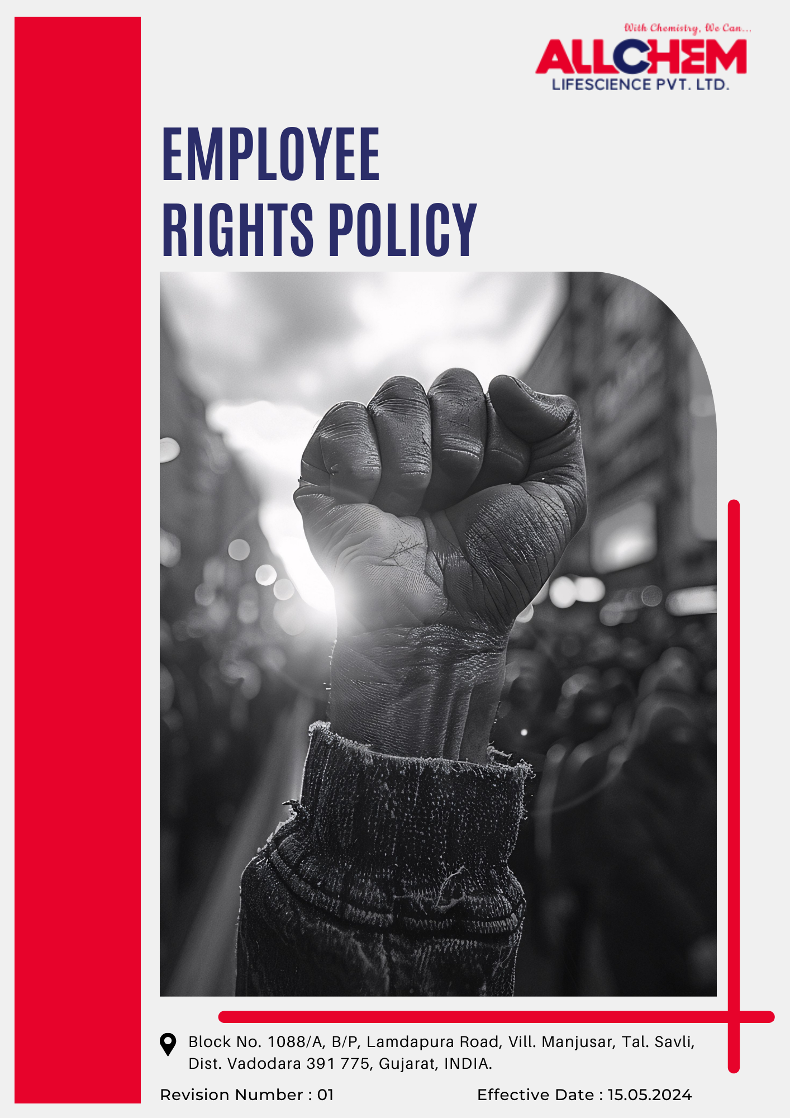
Contents
Preface 3
Scope 3
Policy Declaration 3
Key Action Areas 3
Targets based on our action areas 4
Our Targets in alignment with SDGs 5
Responsibilities 6
Review Mechanism 6
Employee Acknowledgment Form 7

Preface
Employees are the driving force behind Allchem Lifescience Pvt. Ltd., and their rights, safety, and well-being are central to our workplace culture. This policy establishes a framework that safeguards employees from discrimination, harassment, forced labor, and unfair treatment while ensuring fair wages, safe working conditions, and equal opportunities for growth.
We recognize that a respectful and inclusive work environment not only upholds ethical standards but also enhances productivity, innovation, and job satisfaction. By fostering transparency, accountability, and open communication, we aim to create a workplace where every individual is valued, empowered, and treated with dignity. This policy serves as a guiding document for employees and management to uphold fairness, integrity, and human rights in all aspects of our operations.
Scope
This policy applies to all employees, contract workers, and trainees across Allchem Lifescience Pvt. Ltd., covering office spaces, production units, and workplace interactions to ensure their rights are upheld.

Allchem Lifescience Pvt. Ltd. | Block No. 1088/A, B/P, Lamdapura Road, Vill. Manjusar, Tal.-Savli, Dist.-Vadodara -391 775, Gujarat, India.

Policy Declaration

Fairness, integrity, and inclusivity shape the work culture at Allchem Lifescience Pvt. Ltd. Anchored in global labor standards and human rights principles, this policy defines our commitment to ethical employment, workplace safety, and transparent engagement with all stakeholders. With 2022 as the baseline year, we continuously refine our practices through governance, training, and collaboration, ensuring a work environment that upholds dignity, equal opportunity, and compliance with labor laws.

Key Action Areas
- Allchem Lifescience Pvt. Ltd. encompasses multiple critical areas to ensure a fair, safe, and ethical workplace. The key action areas include:
- Implementation of safety protocols, conducting regular risk assessments, and providing health programs to prevent workplace hazards and promote employee well-being.
- Ensuring fair wages, reasonable working hours, and a safe, hygienic environment in compliance with labor laws and industry standards.
- Open communication channels, strengthened grievance redressal mechanisms, and supporting collective bargaining and employee representation.
- Offering continuous learning, skill development, and career growth opportunities to enhance employee potential and organizational progress.
- Ensuring responsible hiring, and hence maintain a workplace free from child labor, forced labor, and human trafficking.
- Maintaing an inclusive culture by ensuring equal opportunities, preventing discrimination, and promoting diverse representation at all levels.
- To uphold human rights across the supply chain by working with ethical suppliers, contractors, and business partners.
- To support flexible work arrangements, leave policies, and wellness initiatives to help employees maintain a healthy work-life balance.
- Ensure a safe and anonymous reporting system for employees to raise concerns about unethical practices without fear of retaliation.
- Conduct regular employee surveys, feedback sessions, and wellness programs to enhance job satisfaction and workplace morale.
Targets based on our action areas
- Ensuring Workplace Health and Safety
- Strengthen workplace safety through risk management, health monitoring, preventive measures, and ensure active employee participation in safety initiatives.
- Conduct annual health and safety training for 100% of employees.
- Maintain Zero workplace injuries till year 2028 through safety training, audits, and improved protective measures.
- Maintain zero fatalities and severe injuries through strict enforcement of safety protocols.
- Improving Workplace Conditions
- Conduct annual employee satisfaction surveys, targeting to achieve 90% satisfaction rate with working conditions by year 2028.
- Ensure all facilities have adequate break areas, clean restrooms, and ergonomic workspaces.
- Conduct workplace condition audit till 2028 to identify and rectify any non-compliance issues.
- Enhancing Employee Engagement
- Improve employee engagement through recognition programs, structured dialogue mechanisms and participation in corporate initiatives.
- Empower employees to voice concerns through formal grievance redressal mechanisms.
- Conduct annual meetings for direct engagement between leadership and employees.
- Work-Life Balance
- Support employees in maintaining a healthy balance between work and personal life by implementing policies that allow flexibility while ensuring productivity.
- Implement flexible work arrangements for at least 30% of employees by 2025.
- Increase participation in wellness programs by 90% by year 2028.
- Maintain 100% employee satisfaction with work-life balance by year 2028, as measured in engagement surveys.

- Supporting Career Growth and Learning
- Provide skill development, career advancement opportunities, and internal mobility while promoting leadership development programs for all employees through structured training, mentorship initiatives, and performance-based growth plans.
- Increase internal promotions by 20% by 2028 through structured career progression programs.
- Implement an internal knowledge-sharing platform to facilitate cross-functional learning, with 50% employee participation by year 2028.
- Establish partnerships with industry experts to conduct guest lectures on sustainable chemistry solutions.
- Child Labor, Forced Labor, and Human Trafficking
- Hold suppliers accountable for ethical labor practices through contractual obligations and regular compliance audits.
- Train 100% procurement and HR teams on ethical labor practices annually.
- Conduct supplier due diligence assessments covering 100% of suppliers by year 2028.
- Ensure strict enforcement of zero-tolerance policy on child and forced labor violations with immediate supplier disengagement.
- Advancing Diversity, Equity, and Inclusion
- Foster a diverse and inclusive workplace by eliminating biases in hiring and promotions and hence maintain a culture where employees from all backgrounds feel valued.
- Attain gender balance across 100% leadership levels by year 2028 through targeted leadership development programs, equitable promotion opportunities, and inclusive hiring policies.
- Ensure 100% of employees undergo annual diversity and inclusion training.
- Enhance career growth for underrepresented groups by providing mentorship, structured career progression frameworks, and leadership development initiatives.
- External Stakeholder Human Rights
- Ensure 100% of key suppliers sign and comply with Allchem’s Supplier Code of Conduct by year 2028.
- Integrate human rights assessments into supply chain due diligence.
- Conduct annual third-party audits on supplier human rights practices.
- Train 100% of procurement and vendor management staff on human rights and ethical sourcing annually.
Our Targets in alignment with SDGs
- SDG 3: Good Health and Well-being – Strengthening workplace safety, health monitoring, and injury prevention measures ensures employee well-being and a safe working environment.
- SDG 4: Quality Education – Providing skill development, mentorship, and industry knowledge-sharing opportunities enhances employee learning and career growth.
- SDG 5: Gender Equality – Achieving gender balance in leadership, implementing inclusive hiring policies, and fostering workplace diversity promote equal opportunities.
- SDG 8: Decent Work and Economic Growth – Ensuring fair wages, ethical labor practices, improved working conditions, and career progression frameworks contribute to sustainable employment and economic growth.
- SDG 10: Reduced Inequalities – Enhancing career pathways for underrepresented groups, promoting workplace equity, and eliminating biases in hiring and promotions ensure equal opportunities for all.
- SDG 12: Responsible Consumption and Production – Conducting human rights assessments in the supply chain and ensuring supplier compliance with ethical labor practices promote sustainable business operations.
- SDG 16: Peace, Justice, and Strong Institutions – Strengthening grievance mechanisms, enforcing zero-tolerance policies on child and forced labor, and conducting supplier due diligence assessments uphold transparency, fairness, and accountability in business practices.
Responsibilities
- The Human Resources Manager ensures policy implementation, compliance with labor and human rights standards, and promotion of workplace ethics.
- Department Heads and Supervisors uphold fair labor practices, maintain a safe and inclusive work environment, and address violations or grievances.
- The Compliance Team conducts evaluations, audits, and risk assessments to identify non-compliance and implement corrective actions.
- Employees and Contractors adhere to workplace ethics, report concerns without retaliation, and participate in training initiatives.
- The Procurement Team ensures supplier compliance with the Supplier Code of Conduct, conducts due diligence audits, and enforces responsible sourcing practices.
Review Mechanism
- The Employee Rights Policy is reviewed every two years or as needed by the Human Resources Manager to ensure alignment with regulations and industry best practices.
- Annual audits evaluate policy effectiveness, identify gaps, and drive necessary improvements.
- Employee and stakeholder feedback is gathered to enhance policy implementation.
- Corrective actions are taken based on audit findings to improve workplace conditions.
- Compliance reports and updates are submitted to senior management for accountability and continuous progress.
- Benchmarking against industry standards ensures leadership in ethical labor practices.

Effective Date | : 15.05.2024
Next Review Date | : 15.05.2026
Approved By | :

Employee Acknowledgment Form
I acknowledge that I have received, read, and understood the Employee Rights Policy of Allchem Lifescience Pvt. Ltd. I agree to adhere to the principles outlined in this policy, including maintaining workplace ethics, promoting fair labor practices, ensuring a safe and inclusive work environment, and upholding human rights.
I understand that it is my responsibility to comply with this policy in my daily work and to report any concerns or violations through the designated channels. I acknowledge that non-compliance may result in disciplinary action as per company regulations.
By signing this acknowledgment, I affirm my commitment to upholding integrity, transparency, and ethical conduct in the workplace.

Employee Name  Employee ID  Date  Signature | :_______________________________  :_______________________________ :_______________________________  :_______________________________

